SUPPLEMENTARY MATERIAL
Search strategies
1. PubMed
#1: (lonel*[Title/Abstract] OR "social withdrawal"[Title/Abstract] OR aloneness[Title/Abstract] OR "felt alone"[Title/Abstract] OR "feeling alone"[Title/Abstract] OR "feel alone"[Title/Abstract] OR "felt social isolation"[Title/Abstract] OR "feel social isolation"[Title/Abstract] OR "feeling social isolation"[Title/Abstract]) AND (Migra*[Title/Abstract] OR Immigra*[Title/Abstract] OR Emigra*[Title/Abstract] OR Foreign*[Title/Abstract] OR evacuee[Title/Abstract] OR expatriate*[Title/Abstract] OR exile*[Title/Abstract] OR deport*[Title/Abstract])

2. Web of Science
#1: lonel* OR "social withdrawal" OR aloneness OR "felt alone" OR "feeling alone" OR "feel alone" OR "felt social isolation" OR "feel social isolation" OR "feeling social isolation" (Title) and Migra* OR Immigra* OR Emigra* OR Foreign* OR evacuee OR expatriate OR exile* OR deport* (Title)

#2: lonel* OR "social withdrawal" OR aloneness OR "felt alone" OR "feeling alone" OR "feel alone" OR "felt social isolation" OR "feel social isolation" OR "feeling social isolation" (Abstract) and Migra* OR Immigra* OR Emigra* OR Foreign* OR evacuee OR expatriate OR exile* OR deport* (Abstract)

#3: #1 OR #2

3. PsycINFO
#1: TI (lonel* OR "social withdrawal" OR aloneness OR "felt alone" OR "feeling alone" OR "feel alone" OR "felt social isolation" OR "feel social isolation" OR "feeling social isolation") AND TI (Migra* OR Immigra* OR Emigra* OR Foreign* OR evacuee OR expatriate OR exile* OR deport*)

#2: AB (lonel* OR "social withdrawal" OR aloneness OR "felt alone" OR "feeling alone" OR "feel alone" OR "felt social isolation" OR "feel social isolation" OR "feeling social isolation") AND AB (Migra* OR Immigra* OR Emigra* OR Foreign* OR evacuee OR expatriate OR exile* OR deport*)

#3: #1 OR #2

4. SCOPUS
#1: (lonel*[Title/Abstract] OR "social withdrawal"[Title/Abstract] OR aloneness[Title/Abstract] OR "felt alone"[Title/Abstract] OR "feeling alone"[Title/Abstract] OR "feel alone"[Title/Abstract] OR "felt social isolation"[Title/Abstract] OR "feel social isolation"[Title/Abstract] OR "feeling social isolation"[Title/Abstract]) AND (Migra*[Title/Abstract] OR Immigra*[Title/Abstract] OR Emigra*[Title/Abstract] OR Foreign*[Title/Abstract] OR evacuee[Title/Abstract] OR expatriate*[Title/Abstract] OR exile*[Title/Abstract] OR deport*[Title/Abstract])

Formulas and Effect Size Calculations for Each Study

The various formulas used to calculate the different effect sizes are presented below.
For the vast majority of the studies, Hedges' g was calculated using the means and standard deviations of each group. We utilized the escalc function with the SMD measure from the metafor package (Viechtbauer, 2010). The formula used was as follows:
$$\frac{mean 1 - mean 2}{sd}$$

$$sd = \sqrt{\frac{(n1 - 1) * {sd1}^{2}+(n2-1)*{sd2}^{2}}{n1+n2-2}}$$

In cases where a paper reported data for multiple distinct groups of migrants or locals, a weighted average of the loneliness score based on group size was calculated prior to computing Hedges' g.
$$Wm = \frac{n1*m1+n2*m2+...+nn*mn}{n1+n2+...+nm}$$

This procedure also required calculating a new pooled standard deviation, which was achieved using the square root of the following formula:
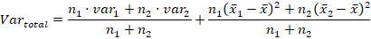

In cases where studies reported subscales separately (specifically, Boudouda & Kamel, 2016; Diehl et al., 2018; Fierloos et al., 2021), we employed the aggregate function from the metafor package. This allowed us to compute a combined effect size while properly accounting for the correlations between factors.
For a subset of studies (Achdut and Refaeli, 2021; De Witte & Van Regenmortel, 2021; Delaruelle, 2023; Islam & Gilmour, 2023; Lin, 2023; Refaeli & Achdut, 2024; Rich Madsen et al., 2016; Zheng et al., 2024), the reported Odds Ratios (OR) were transformed using the OR2DN function from the metafor package, applying the following formulas:

Lastly, for a single study (Fokkema and Naderi, 2013), Hedges' g was calculated from the F-statistic using the formula below. This specific calculation was performed using base R functions.
$$d = 2*\sqrt{\frac{F}{N}}$$
Subsequently, d was transformed into g.
No other data types allowing for the derivation of Hedges' g scores were encountered across the included studies.

Coding Procedures for Moderator Variables
For the moderator variables, the pooled percentage of women was calculated across all subsamples included in the analysis for each study. Unless the complete samples from a given study were utilized, the overall aggregate data reported in the original papers were bypassed.
Regarding mean age, the reported mean was extracted if the full sample was analyzed. However, if only a subset of participants was included, or if the study failed to provide overall age means, a pooled mean age was computed by weighting each analyzed subgroup by its respective sample size. Given that mean ages could not be retrieved for all cases, we also categorized studies into age brackets according to the following logic:
Age group: 0 = children and adolescents (less than or equal to 18 years), 1 = adults (greater than 18 and less than or equal to 60 years), 2 = older adults (greater than 60 years), 3 = mixed age groups. To be classified under categories 0 to 2, it was strictly required that 100% of the sample fell within that specific range. If participants spanned two or more age brackets, the study was categorized as 3 (mixed age groups). To access this information, the description provided in the participants section was reviewed, paying specific attention to the reported age ranges.
To classify studies by measurement instrument, the methodology section of each paper was reviewed, using the following coding scheme: 0 = Asher Loneliness Scale, 1 = De Jong Gierveld Loneliness Scale, 2 = UCLA Loneliness Scale, 3 = other instruments or single item. If a study employed any validated version or length variation of the scales coded as 0, 1, or 2, it was assigned to that specific category. To avoid an excessive number of categories that would hinder the analysis, the "other" classification was reserved exclusively for single items or less used measures (e.g., Boudouda and Kamel, 2016).

Table S1. Articles excluded after full-text screening
No. | Study (First author, year/title) | Reason for exclusion
1 | Anaya, 2024. Locked down in distress: A quasi-experimental estimation of the mental-health fallout from the COVID-19 pandemic | Loneliness not assessed as relevant outcome
2 | Baek, 2024. Loneliness among low-income older immigrants living in subsidized senior housing: Does perceived social cohesion matter? | Ineligible publication type
3 | Bandyopadhyay, 2010. Life with a new baby: how do immigrant and Australian-born women's experiences compare? | Loneliness not assessed as relevant outcome
4 | Barret, 2013. Social isolation, loneliness and return migration: Evidence from older Irish adults | No appropriate migrant vs non-migrant comparison group
5 | Chatzigeorgiadou, 2011. Differences in loneliness and social behavior of immigrant and repatriated preschoolers | Ineligible publication type
6 | Chen, 2010. Social and psychological adjustment of Chinese Canadian children | No appropriate migrant vs non-migrant comparison group
7 | Chen, 2025. Loneliness among older caregivers: An analysis of the 2020 California Health Interview Survey | Full text could not be retrieved
8 | Chen, 2024. Association between different patterns of social participation and loneliness among the Chinese older people: is there a local-migrant gap? | No appropriate migrant vs non-migrant comparison group
9 | Cheung, 2023. Frailty, quality of life, and loneliness of aging in native and diasporic | Insufficient data to compute effect size
10 | Corsano, 2019. Solitude and loneliness profiles in early adolescents: A Person-Centred Approach | No appropriate migrant vs non-migrant comparison group
11 | Da Jiang, 2019. Everyday solitude affective experiences and well-being in old age the role of culture versus immigration | Loneliness not assessed as relevant outcome
12 | Dolberg, 2016. Migration and changes in loneliness over a 4-year period: the case of older former Soviet Union immigrants in Israel | No appropriate migrant vs non-migrant comparison group
13 | Ge, 2024. Elevated levels of loneliness in migrant children compared to nonmigrant children in urban China: a systematic review and meta-analysis of comparative studies | Full text could not be retrieved
14 | Gierveld, 2012. Older immigrants in Canada: Socially integrated or confronted with feelings of loneliness? | Ineligible publication type
15 | Hajek, 2024. [Migration background and loneliness among middle-aged and older adults in Germany] Article in German | No appropriate migrant vs non-migrant comparison group
16 | Hyeon, 2022. Social isolation and loneliness among older adults in subsidized senior housing: Does immigration status matter? | Ineligible publication type
17 | Jeong, 2022. Social isolation and loneliness among older adults in subsidized senior housing: does immigration status matter? | Ineligible publication type
18 | Leung, 2001. The psychological adaptation of overseas and migrant students in Australia | No appropriate migrant vs non-migrant comparison group
19 | Lin, 2009. The effect mechanism of stigma perception on mental health among migrant children in Beijing | Full text could not be retrieved
20 | Lin, 2024. The effect of peer relationships on loneliness: A moderated mediation model | No appropriate migrant vs non-migrant comparison group
21 | Lu, 2020. Understanding the relationship between loneliness and immigration-related factors in older adults in Ontario, Canada. | Ineligible publication type
22 | Neto, 2000. Predictors of loneliness among adolescents from Portuguese immigrant families in Switzerland | No appropriate migrant vs non-migrant comparison group
23 | Neto, 2002. Loneliness and acculturation among adolescents from immigrant families in Portugal | Loneliness not assessed as relevant outcome
24 | Neto, 2010. Happiness among Portuguese and Indian adolescents from immigrant families in Portugal | Loneliness not assessed as relevant outcome
25 | Neto, 2016. Predictors of loneliness among Portuguese youths from returned migrant families | No appropriate migrant vs non-migrant comparison group
26 | Pang, 2024. The migrant-local difference in the relationship between social support, sleep disturbance, and loneliness among older adults in China. Cross-sectional study | Overlapping sample
27 | Read, 2024. The cohort trends of social connectedness in secondary school students in Finland between 2017 and 2021 | Loneliness not assessed as relevant outcome
28 | Refaeli, 2024. Ethnocultural Disparities in Loneliness Among Women in Israel: A Population-Based Study | Duplicate
29 | Rich Madsen, 2016. Loneliness, immigration background and self-identified ethnicity: a nationally representative study of adolescents in Denmark | Overlapping sample
30 | Savaş, 2025. Trouble in paradise? Emotional and social loneliness among international retirement migrants | Insufficient data to compute effect size
31 | Strohmeier, 2003. Immigrant Children in Austria: Aggressive behavior and friendship patterns in multicultural school classes | No appropriate migrant vs non-migrant comparison group
32 | van Bergen, 2008. Suicidal ideation in ethnic minority and majority adolescents in Utrecht, the Netherlands | Loneliness not assessed as relevant outcome
33 | van den Broek, 2017. Loneliness among Polish migrants in the Netherlands: The impact of presence and location of partners and offspring | No appropriate migrant vs non-migrant comparison group
34 | Van Tilburg, 2018. [Stronger feelings of loneliness among Moroccan and Turkish older adults in the Netherlands: A search for an explanation] Article in Dutch | Overlapping sample
35 | Xiang, 2007. The relation of migrant workers' children's and parental rearing behavior | Full text could not be retrieved
36 | Salari, 2025. Global prevalence of loneliness in immigrants: A systematic review and meta-analysis | Ineligible publication type

Table S2. The JBI critical appraisal tool for cross-sectional studies included in the systematic review (n=35).
Study | Q1 | Q2 | Q3 | Q4 | Q5 | Q6 | Q7 | Q8 | Overall risk score | Quality rating
Achdut & Refaeli, 2021 | yes | yes | no | yes | yes | yes | unclear | yes | 6 | Low risk of bias
Baumbach et al., 2023 | yes | yes | yes | yes | yes | yes | yes | yes | 8 | Low risk of bias
Bilecen et al., 2025 | no | yes | yes | yes | yes | yes | unclear | yes | 6 | Low risk of bias
Boudouda et al., 2017 | yes | yes | no | yes | yes | yes | yes | yes | 7 | Low risk of bias
de Jong Gierveld et al., 2015 | yes | yes | yes | yes | yes | yes | yes | yes | 8 | Low risk of bias
Delaruelle, 2023 | no | yes | yes | yes | yes | yes | yes | yes | 7 | Low risk of bias
Devos et al. 2024 | yes | yes | yes | yes | yes | yes | yes | yes | 8 | Low risk of bias
De Witte & Van Regenmortel, 2022 | yes | yes | yes | yes | yes | yes | yes | yes | 8 | Low risk of bias
Diehl et al., 2018 | yes | yes | yes | yes | yes | yes | yes | yes | 8 | Low risk of bias
Fandrem et al. 2021 | no | yes | no | yes | yes | yes | yes | yes | 6 | Low risk of bias
Fierloos et al., 2021 | yes | yes | yes | yes | yes | yes | yes | yes | 8 | Low risk of bias
Fokkema & Naderi, 2013 | no | yes | no | yes | yes | yes | yes | yes | 6 | Low risk of bias
Hsu et al., 1987 | yes | yes | yes | no | no | no | yes | yes | 5 | Moderate risk of bias
Islam & Gilmour, 2023 | yes | yes | yes | yes | yes | yes | yes | yes | 8 | Low risk of bias
Jerusalem, 1988 | no | yes | no | yes | yes | yes | yes | yes | 6 | Low risk of bias
Jones et al., 2019 | no | yes | no | yes | yes | yes | yes | yes | 6 | Low risk of bias
Koelet & De Valk, 2016 | yes | yes | no | yes | yes | yes | yes | yes | 7 | Low risk of bias
Lam, 2021 | no | yes | no | yes | yes | no | yes | yes | 5 | Moderate risk of bias
Leondari 2001 | yes | yes | no | yes | yes | yes | yes | yes | 7 | Low risk of bias
Lin, 2023 | yes | yes | yes | yes | yes | yes | yes | yes | 8 | Low risk of bias
Liu et al. 2025 | yes | yes | yes | yes | yes | yes | yes | yes | 8 | Low risk of bias
Löbel et al., 2022 | yes | yes | no | yes | yes | yes | yes | yes | 7 | Low risk of bias
Lu et al, 2023 | yes | yes | yes | yes | yes | yes | yes | yes | 8 | Low risk of bias
Nykänen et al., 2024 | yes | yes | no | yes | yes | yes | no | yes | 6 | Low risk of bias
Pan et al., 2023 | yes | yes | yes | yes | yes | yes | yes | yes | 8 | Low risk of bias
Polo & Lopez, 2009 | yes | yes | yes | yes | yes | yes | yes | yes | 8 | Low risk of bias
Refaeli & Achdut, 2024 | yes | yes | no | yes | yes | yes | unclear | yes | 6 | Low risk of bias
Rich Madsen et al., 2016 | yes | yes | no | yes | yes | yes | unclear | yes | 6 | Low risk of bias
Strohmeier et al., 2012 | yes | yes | no | yes | yes | yes | yes | yes | 7 | Low risk of bias
Ten Kate et al., 2020 | yes | yes | yes | yes | yes | yes | yes | yes | 8 | Low risk of bias
Van Tilburg & Fokkema, 2020 | yes | yes | yes | yes | yes | yes | yes | yes | 8 | Low risk of bias
Wen et al., 2010 | yes | yes | yes | yes | yes | yes | yes | yes | 8 | Low risk of bias
Wu et al., 2022 | yes | yes | yes | yes | yes | yes | yes | yes | 8 | Low risk of bias
Wu & Penning, 2015 | yes | yes | yes | yes | yes | yes | yes | yes | 8 | Low risk of bias
Zheng et al., 2024 | no | yes | yes | yes | yes | yes | yes | yes | 7 | Low risk of bias

Note. Q1. Were the criteria for inclusion in the sample clearly defined? Q2. Were the study subjects and the setting described in detail? Q3. Was the exposure measured (migration) in a valid and reliable way? Q4. Were objective, standard criteria used for measurement of the condition? Q5. Were confounding factors identified? Q6. Were strategies to deal with confounding factors stated? Q7. Were the outcomes (loneliness) measured in a valid and reliable way? Q8. Was appropriate statistical analysis used?

Table S3. The JBI critical appraisal tool for longitudinal studies included in the systematic review (n=5).
Study | Q1 | Q2 | Q3 | Q4 | Q5 | Q6 | Q7 | Q8 | Q9 | Q10 | Q11 | Overall risk score | Quality rating
Amendola & von Wyl, 2024 | yes | yes | no | yes | yes | yes | unclear | yes | yes | yes | yes | 9 | Low risk of bias
Lu & Zhou, 2013 | yes | yes | yes | yes | yes | yes | yes | yes | yes | yes | yes | 10 | Low risk of bias
Sheftel et al., 2023 | yes | yes | yes | yes | yes | yes | yes | yes | yes | yes | yes | 11 | Low risk of bias
Tani et al., 2022 | yes | yes | no | yes | yes | yes | yes | yes | yes | yes | yes | 10 | Low risk of bias
Tartakovsky, 2009 | yes | yes | no | yes | yes | yes | yes | yes | yes | yes | yes | 10 | Low risk of bias

Note. Q1. Were the two groups similar and recruited from the same population? Q2. Were the exposures measured similarly to assign people to both exposed and unexposed groups? Q3. Was the exposure measured (migration) in a valid and reliable way? Q4. Were confounding factors identified? Q5. Were strategies to deal with confounding factors stated? Q6. Were the groups/participants free of the outcome (loneliness) at the start of the study (or at the moment of exposure)? Q7. Were the outcomes (loneliness) measured in a valid and reliable way? Q8. Was the follow up time reported and sufficient to be long enough for outcomes to occur? Q9. Was follow up complete, and if not, were the reasons to loss to follow up described and explored? Q10. Were strategies to address incomplete follow up utilized? Q11. Was appropriate statistical analysis used?

Figure S1. Trim and Fill Funnel Plot
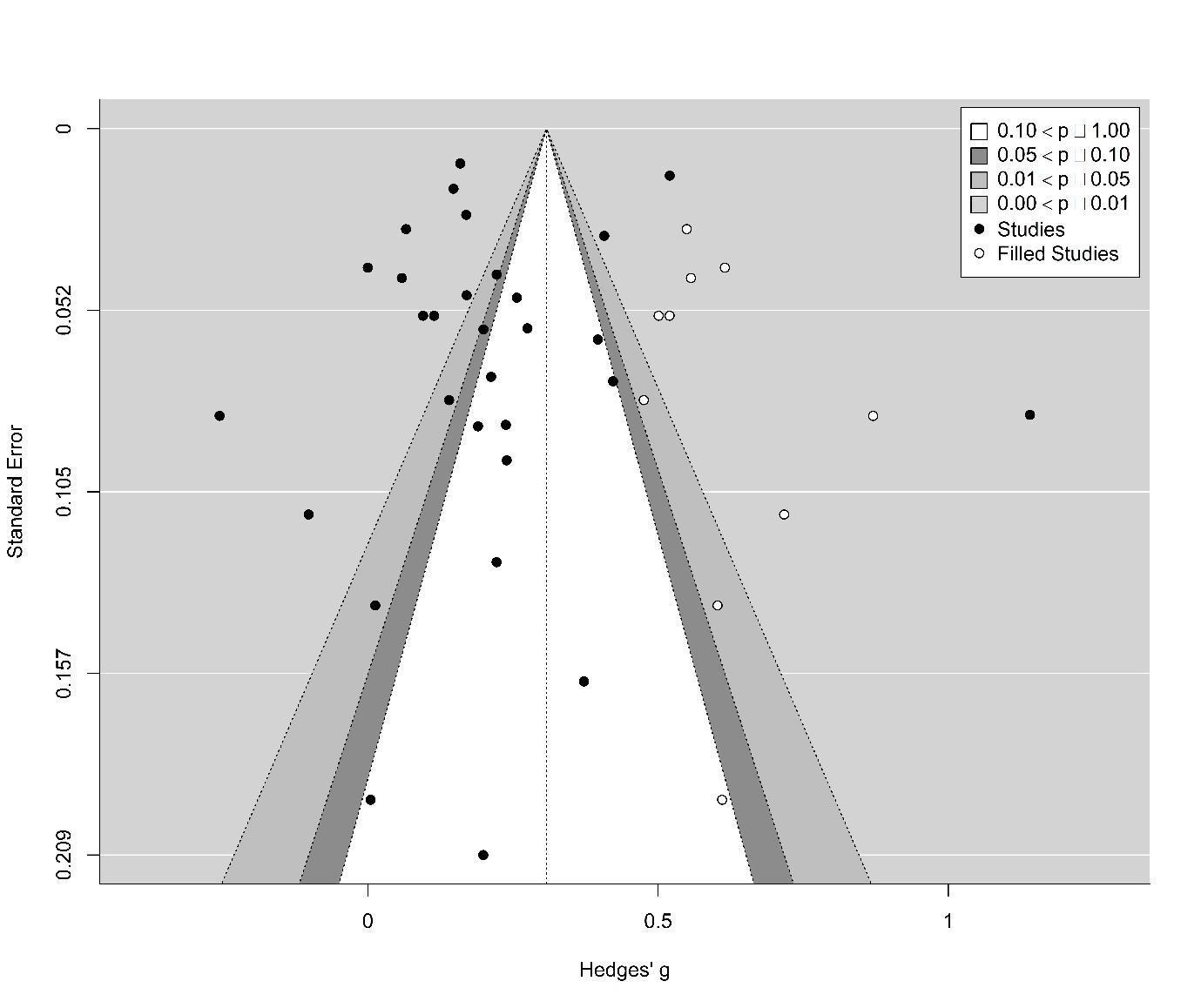
Table S4. Analysis of categorical moderators
 | Q_{moderator} | Q_{Residual} | g
Age group | Q (3) = 0.861 | Q (26) =739.32**
Adolescent (k=6) |  |  | 0.13 (-0.08; 0.34)
Adult (k=6) |  |  | 0.25 (0.06; 0.45) *
Older adult (k=13) |  |  | 0.23 (0.10; 0.37) **
Mixed (k=5) |  |  | 0.19 (-0.02; 0.40)
Test used | Q (3) =7.030 | Q (26) = 701.961**
Asher (k=4) |  |  | 0.27 (0.03; 0.50) *
De Jong (k=8) |  |  | 0.36 (0.21; 0.51) **
UCLA (k=10) |  |  | 0.09 (-0.04; 0.23)
Other (k=8) |  |  | 0.19 (0.04; 0.35) *

Note. ** 0.01 * 0.05

